**KISAASI COLLEGE SCHOOL**

**END OF TERM III ASSESSMENT 2023**

**S2 PHYSICS (Competence Based Curriculum)**

**Time: 2 hours:**

**NAME: ……………………………………………………………………………………………………………………………………….**

**Attempt all questions**

**1. Ali moved out of the house early in the morning and he saw his picture on the ground moving along with him. He attributed this to witchcraft. As a physics learner explain to him what was the picture. (04 marks)**

**………………………………………………………………………………………………………………………………………………………………………………………………………………………………...................................................................................………………………………………………………………………………………………………………………………………………………………………………………………………………………………..............................................................................................................................................................**

**b) Give two properties of images formed by**

**(i) pinhole cameras (02 marks)**

**………………………………………………………………………………………………………………………………………………………………………………………………………………………………...........................................................................................................................**

**(ii) Plane mirrors (02 marks)**

**…………………………………………………………………………………………………………………………………………………………………………………………………………………………………………………………………………………………………………………………………………………………………………………………………………………………………………………………………………………….**

**(c) State the laws of reflection of light. (02 marks)**

**………………………………………………………………………………………………………………………………………………………………………………………………………………………………............................................................................................................................................................................................................................................................................**

**2 (a) Distinguish between potential energy and kinetic energy. (02 marks)**

**………………………………………………………………………………………………………………………………………………………………………………………………………………………………............................................................................................................................................................................................................................................................................**

**(b) Two forces of 5N and 12N acts at right angles on a block. Find the resultant force on the block. (03 marks)**

**………………………………………………………………………………………………………………………………………………………………………………………………………………………………...................................................................................………………………………………………………………………………………………………………………………………………………………………………………………………………………………...............................................................................................................................................................**

**3 (a) State the principle of moments (02 mark)**

**………………………………………………………………………………………………………………………………………………………………………………………………………………………………...........................................................................................................................**

**(b) A Car of mass 90kg at a distance of 6m from side A of a bridge, moves along a uniform bridge of length 16.0m and weight 20N. If the bridge was supported by two stands at its ends, Find the reactions at the supports. (05 marks)**

**………………………………………………………………………………………………………………………………………………………………………………………………………………………………...................................................................................……………………………………………………………………………………………………………………………………………………………………………………………………………………………….............................................................................................................................................................**

**(c) What are the 3 states of equilibrium? Use diagrams to illustrate them. (03 marks)**

**………………………………………………………………………………………………………………………………………………………………………………………………………………………………...................................................................................………………………………………………………………………………………………………………………………………………………………………………………………………………………………..................................................................................................................................................................................................................................................................................................................4 (a) A stone of 20g was released from a height of 20m. Find its potential energy. (03 marks)**

**………………………………………………………………………………………………………………………………………………………………………………………………………………………………...................................................................................…………………………..…………………………………………………………………………………………………………………………………………………………………………………………………….............**

**(b) Nangulu and Karambazi wanted to visit their friend Natogo in a village, they reached when she was in the swampy garden digging. Nangulu was putting on high healed shoe, and so she was stopped to reach there. Why do you think she was stopped. (03 marks)**

**………………………………………………………………………………………………………………………………………………………………………………………………………………………………...................................................................................…………………………..………………………………………………………………………………………………………**

**(d) A cuboid of dimensions 15cm by 5cm by 10cm has a mass of 10kg. Find its maximum pressure. (04 marks)**

**………………………………………………………………………………………………………………………………………………………………………………………………………………………………...................................................................................………………………………………………………………………………………………………………………………………………………………………………………………………………………………...............................................................................................................................................................**

**5. Give 3 types of simple machines and their application in real life. (06 marks)**

**………………………………………………………………………………………………………………………………………………………………………………………………………………………………...................................................................................………………………………………………………………………………………………………………………………………………………………………………………………………………………………..................................................................................................................................................................................................................................................................................................................**

**(b) Why do you think machines are never 100% efficient? (02 marks)**

**………………………………………………………………………………………………………………………………………………………………………………………………………………………………...........................................................................................................................**

**(c) Draw a system of 3 pulleys and state the velocity ratio. (02 marks)**

**………………………………………………………………………………………………………………………………………………………………………………………………………………………………...................................................................................…………………………………………………………………………………………………………………………………………………………………………………………………………………………………………**

**SECTION B ( choose one question)**

**6. Tom shaves his beard at the end of each week. He bought a shaver, brush, Shampoo and mirror.**

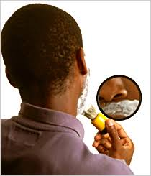

**(a) By observing the figure above, do you which type mirror you think teacher Tom bought. Explain your reasoning. (2 scores)**

**(b) Do you think that teacher Tom's mirror is similar to a car side mirror? Support your answer. (03 scores)**

**7.Abdallah is a business man. He constructed a store yard building of 1 floor to keep his properties. He then installed an overhead tank on the ground level to supply him with water. After two years, He got his savings from the bank and added other 2 floors on his building up to level 3 floor. The people on the 2nd and 3rd level kept on complaining that water cannot reach into their taps. As a S.2 learner, explain what was the cause of the problem how would you solve it. 10 scores)**

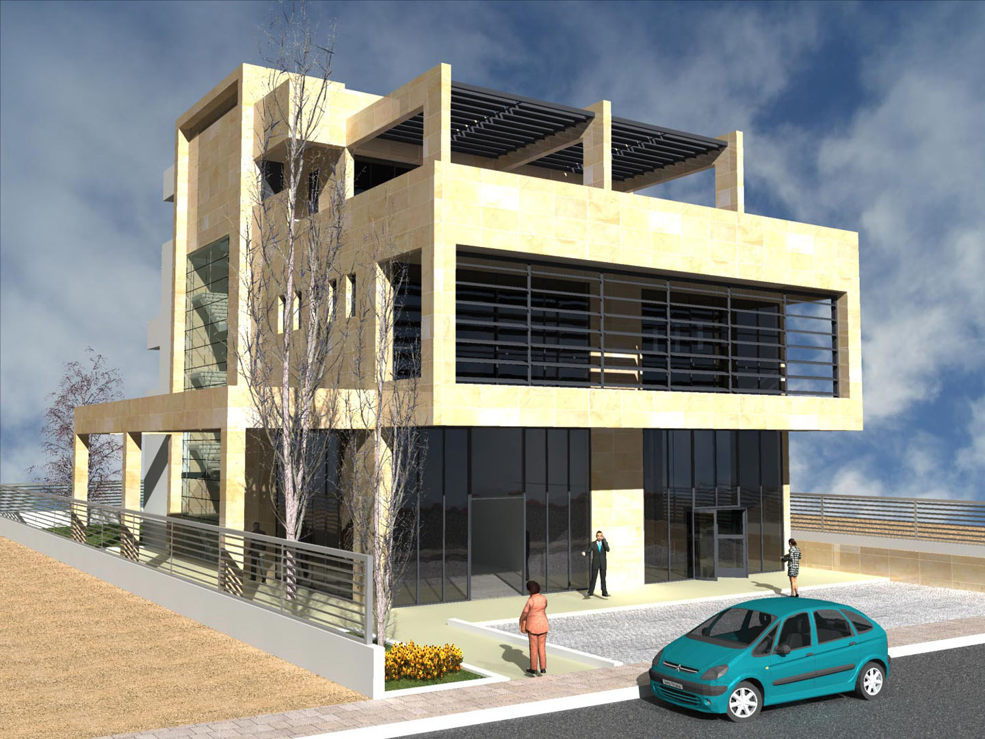

SECTION B ANSWERS.

……………………………………………………………………………………………………………………………………………………………………………………………………………………………………………………….**………………………………………………………………………………………………………………………………………………………………………………………………………………………………...................................................................................………………………………………………………………………………………………………………………………………………………………………………………………………………………………..................................................................................................................................................................................................................................................................................................................**……………………………………………………………………………………………………………………………………………………………………………………………………………………………………………………….**………………………………………………………………………………………………………………………………………………………………………………………………………………………………...................................................................................………………………………………………………………………………………………………………………………………………………………………………………………………………………………..................................................................................................................................................................................................................................................................................................................**……………………………………………………………………………………………………………………………………………………………………………………………………………………………………………………….**………………………………………………………………………………………………………………………………………………………………………………………………………………………………...................................................................................……………………………………………………………………………………………………………………………………………………………………………………………………………………………….......................................................................**

END.